Step 1: Set Up Your Spring Boot Project

1. Generate a Spring Boot Project: Use Spring Initializr (<https://start.spring.io/>) to generate a new project. Choose the following options:
   * Project: Maven Project
   * Language: Java
   * Spring Boot: Latest version
   * Group: com.example
   * Artifact: springbootrest
   * Name: springbootrest
   * Description: A REST API with Spring Boot
   * Package Name: com.example.springbootrest
   * Packaging: Jar
   * Java: 11 or newer
   * Dependencies: Spring Web, Spring Data JPA, PostgreSQL Driver
2. Import the Project: Import the generated project into your IDE.
3. Or you just update your existing dependency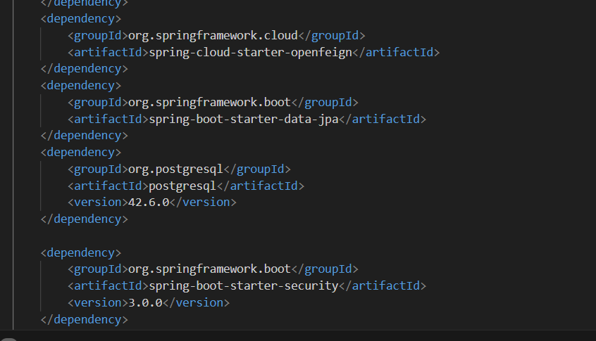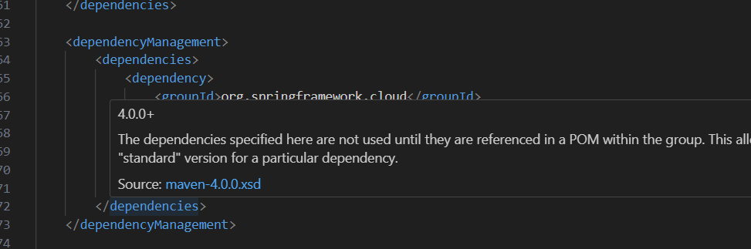A black background with blue text

   Description automatically generated

Step 2: Configure Database Connection

1. Add PostgreSQL Driver: Ensure the PostgreSQL JDBC driver is included in your pom.xml. It should be automatically added by Spring Initializr if you selected PostgreSQL Driver during project generation.
2. Configure application.properties: Open the src/main/resources/application.properties file and add your PostgreSQL database connection details:

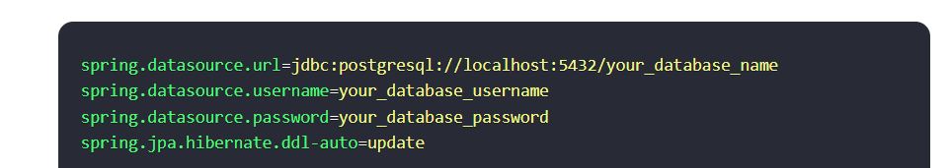

Step 3: Create the User Entity

1. Create the User Entity Class: Create a User entity class in the com.starter.springstarter.model package.

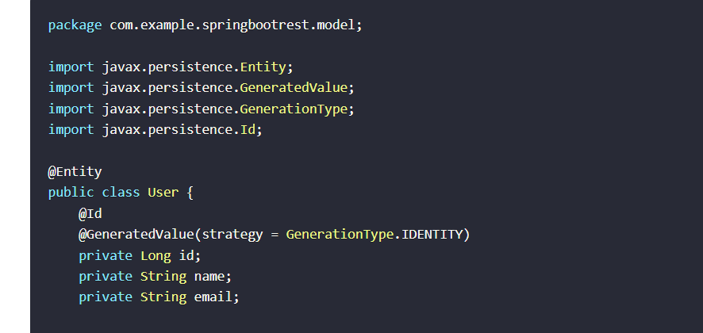

Add base entity.

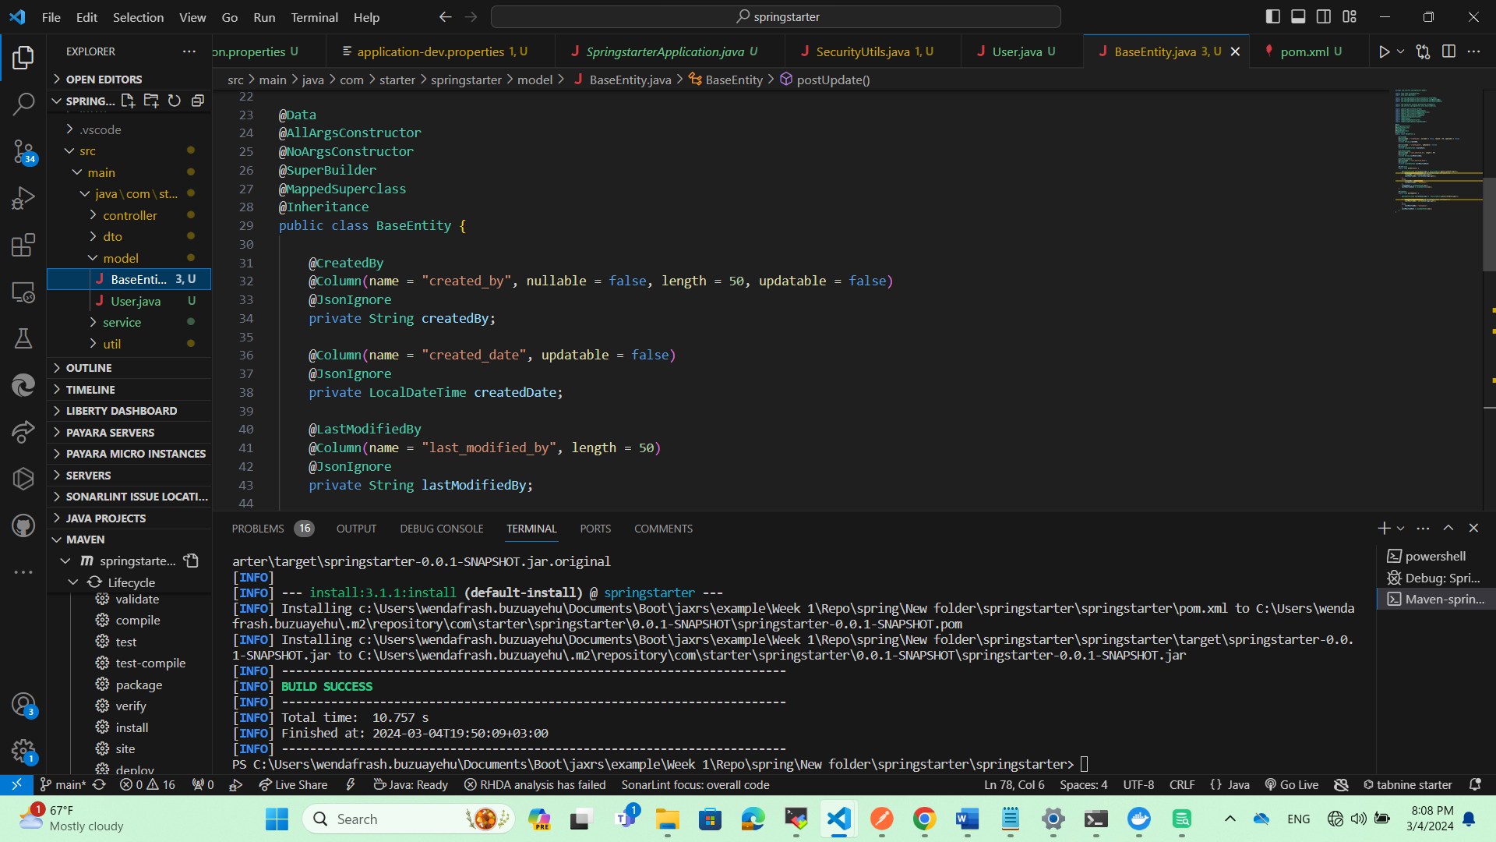

Update User class.

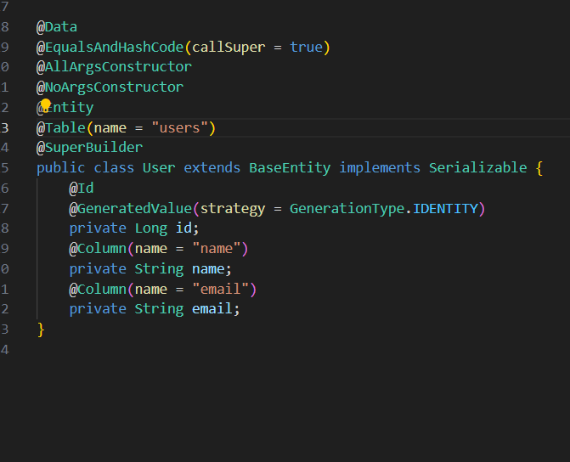

Create a repository folder.

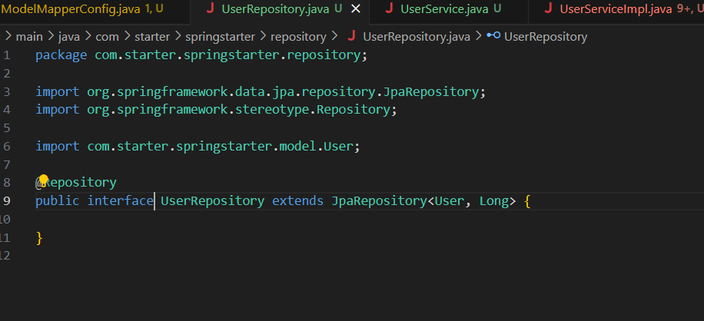

Create a service.

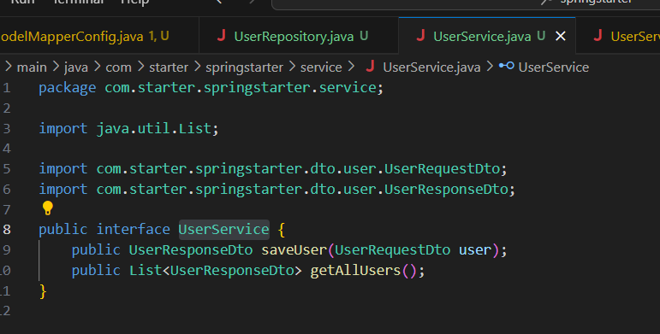

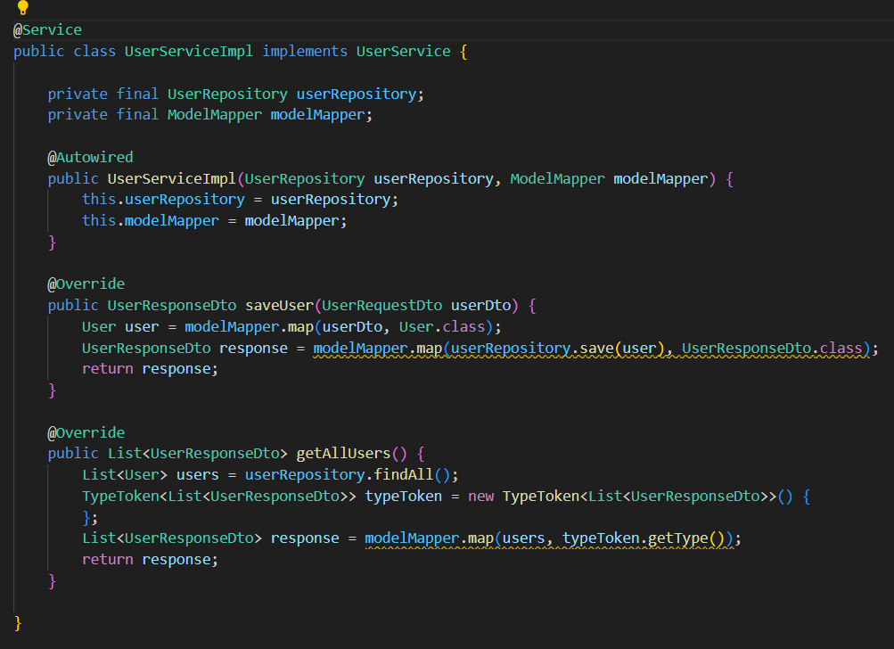

Adding spring security

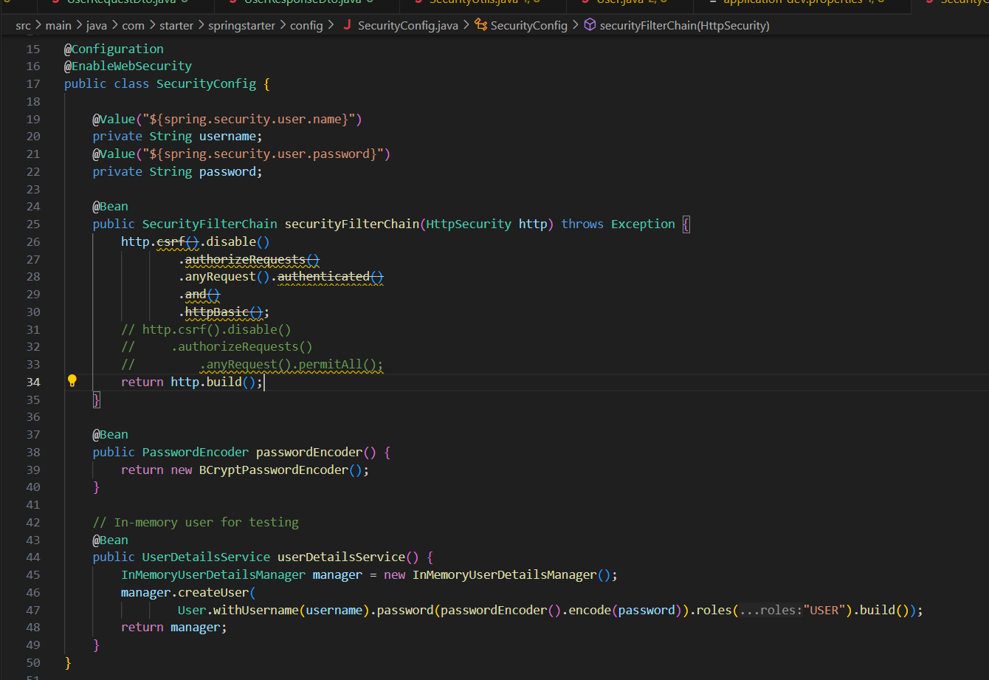

When it runs it should create the database table

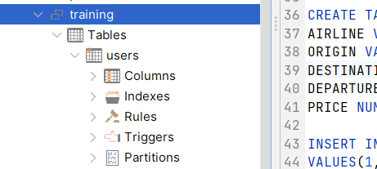

Since we are using create for ddl-auto

